**1. INTRODUCTION**

The technology has so far targeted mainly our sense of sight and sound. To further enhance the virtual reality experience and another flavor to it, technology is now targeting your nose and tongue. The application area of virtual reality is vast- from normal entertainment to the Internet and e-commerce application. You will be able to smell product before buying them online. California-based Digiscents Inc. has developed the iSmell personal scent synthesizer. This small device connects through your pc via serial port and has its own driver.

In this modern age, computers have verified the cause of their existence. They have virtually taken over in every field of today’s fast life. Gone are the days when applications of computers were limited to official use only. Today computers have important place in every household purpose, and mainly internet has taken over whole world.There are various causes due to which computers have their own stand in our life. It provides a very good facility of fast processing, sound and picture. The virtual reality concept has provided very good features to the computer systems. The concept of virtual reality is introduced by the computer programmers to provide more attachments to the user. There are several concepts of the virtual reality that are available such as digital smell, virtual theater, electronics hand gloves, multipoint surround sound system, 3d goggles. The digital smell is basically a hardware software combination. The hardware part of digital smell will produce the smell, and the software part will evaluate the smell equation and generate specific signals for specific smell and finally that smell will be produced by the device. The hardware device is a device like speaker, like speaker this device is also connected to the computer system. For this device there is also a driver program which will evaluate the digital equation for generating specific gas.Until now, online communication involved only three of our senses hearing, touch, and sight. New technology is being developed to appeal to our sense of smell. DigiScents, an interactive media company, is creating iSmell Digital Scent Technology, new software which will enable scents to be broadcast from the Web.

**1.1 PHYSIOLOGICAL ASPECTS OF SMELL**

Before we describe the possibilities of olfactory displays, we should take a glance at the physiological aspects of smell. How does the nose work and what is its function? Naturally we can breath, smell and additionally taste with our nose. First of all we are interested in the anatomy of the nose.

Odor consists of many different molecules, for e.g. the aroma of coffee is made up of 20 various molecules. Nonetheless our nose perceives only 15 odors which is enough to identify the smell as coffee.

At first the odor molecules reach the olfactory mucosa. The receptors for the molecules are placed at the olfactory hairs. When the molecules reach the receptors, an electric impulse is sent directly to the brain to the olfactory bulb. Then the information gets to the olfactory glomeruli, a part of the olfactory bulb. The glomeruli is able to associate the information to the intensity. The olfactory bulb consequently processes the odor and can send the impulse to the olfactory brain. We notice that we have a direct connection between our sense of smelling and our brain. Those scent impulses reach the area of our brain that handles emotions and memories. That explains the link between smelling and being reminded of something.

We percept smell very individually. Every human perceive a difference between a pleasant and unpleasant odor. Humans are not capable to distinguish odors in terms of intensity. Roughly we can only distinguish between three concentrations of some odor whereas we should actually be able to differentiate1000types of odors. Another problem for olfactory display is the fast acclimatization of humans to scents.

What makes it even more difficult to construct olfactory display is that a set

of primary odors has not really been found. There was an attempt to define seven

such of primary odors but had to be extended to 100 odors. For vision, three base colors are sufficient to display any color. Unfortunately this cannot be applied to olfaction as our nose has thousands of receptors and apart from that the odors are not orthogonal. That means you will not necessarily get a new one by mixing two odors. Due to these big problems there is still research in examining our scent.

**2.** **EVOLUTION OF DIGITAL SMELL**

**2.1 How it was Invented**

As we know that many scientists have started for the virtual reality from the last 5 to 6 years. As a virtual reality they have got a full concept as virtual theater. These theaters consist of an electronic hand gloves, digital smell, multipoint surround sound system, movement controllable seats, 3d goggles. From this idea the multipoint surround sound system, 3d goggles, movement controllable seats were completed. Now for the user to fill more realistic effects of movies they were introducing the very new facility of digital smell in movies or in games. For example if we are watching a movie and we see burning of tier then we will fill that smell in theater or pc or television.

The basic idea for this was given by the perfume making companies for the advertisements of their perfumes.

**2.2 Founders**

Founders Dexster Smith and Joel Lloyd Bellenson, experts in bioinformatics and genomics,started from the following idea: “If we can find the essence of a biological smell and build a profile, we can digitalize and broadcast it.” They came up with the idea for the company while they were in South Beach. Using their scientific knowledge, they indexed and analyzed natural smells said to be common to South Beach such as flowers, salt water, and suntan lotion.

**3. PRINCIPLES FOLLOWED**

**3.1 BASIC PRINCIPLE OF E-NOSE**

An electronic nose can be a modular system comprising of active materials which operate serially on an odorant sample. These active materials can be classified into two: an array of gas sensors and a signal processing system.

The output of the electronic nose can be the identification of the odorant, an estimation of the concentration of the odorant or the characteristic of the odor as might be perceived by the human.

Fundamental of artificial nose is that each sensor in the array has different sensitivity. The pattern of response across the sensors is distinct for different odors. The distinguishably allows the system to identify the unknown odor from the pattern of sensor responses. The pattern of response across all the sensors in the array is used to identify the odor. Different e-noses use different types of gas sensors which form heart of e-nose.

**3.2 SENSING AN ORDANT**

In a typical e-nose, an air sample is pulled by a vacuum pump through tube into a small chamber housing the electronic sensor array. Next the sample planning units exposes the sensor to the ordant, producing a transient response as the VOC’s interact with the surface and bulk of sensor’s machine, a steady stste condition is reached in a few seconds to a few minutes.During this interval, the sensor’s response is recorded and delivered to the signal processing unit. Then a washing gas such as alcoholic vapor is applied to the array so as to remove the odorant mixture from the surface and bulk of sensor’s active material. The period during which odorant is applied is called the response time of the sensor array. The period during which washing and reference gases are applied is called the recovery time.The sensor’s response is converted into electronic signal by using a transducer and is processed by using the signal processing unit.

**4. HARDWARE DEVICES**

**4.1 Smell Synthesizer**

The smell synthesizer mean the device which is used to generate the smells. Such as ismell is device used to produce the gas using computer.There are various types of smell synthesizers available in the market, but for computer the smell synthesizer is made by digiscents industry.

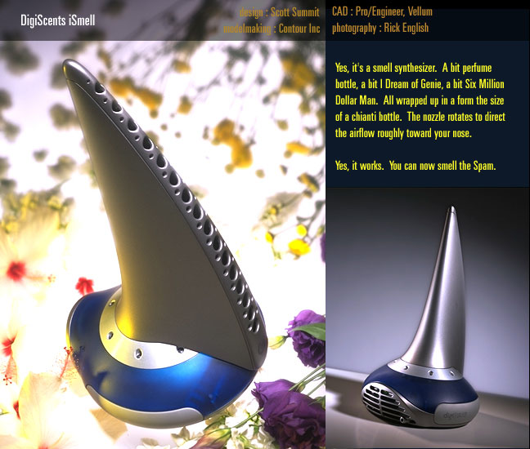

**4.2 iSMELL**

The iSmell is a peripheral device, about the size of a PC speaker that connects to a PC via a serial or USB port. It uses consumable cartridges which are used and replaced similar to the way ink jet printers use ink cartridges. It emits natural-based vapors into the user's personal space. ISmell is triggered either on demand by the user (via a keyboard or mouse action) or via a timed or programmed response (as is the case with a DVD ScentTrack).The company's technology turns smells into digital codes that can be stored on laser discs or as computer files, and can even be e-mailed. The iSmell device reads a digital scent file, creates a smell from a "palette'' of 128 chemicals stored in a cartridge, and then wafts into the air with a small fan.



**Fig: iSmel version**

**4.3 Cartridge**

The cartridge will contain chemicals either natural oils or synthetic fragrances that will be activated by either heat or air pressure, when you send a signal from your computer. The digital smell device could add another sensory dimension to the sights and sounds of a computer game. Currently 128 chemicals are stored in a cartridge. Similar to an ink jet printer, those oils form the core of a replaceable cartridge, which is inserted in the company's iSmell device. The oils are electrically stimulated in different combinations to create specific smells in response to software prompts programmed into applications such as Web site features, computer games, digital music, and movies. But after some time as user will be more familiar with these smells the cartridge will come in market in which you can add chemicals as many as you want. They are still investigating all the scent combinations that are currently possible with the iSmell device. As the technology becomes more refined, more and more scents and scent combinations will be possible.



**Cartridge**

"The idea would be to have a box about the size of a small speaker that would be connected to your computer and within that box is this cartridge of odors, having a hundred different small chambers in it, and then on command from the computer, you can choose various odors within that hundred, to be mixed up together and then puffed gently out of this port where you can smell it."

**4.4 Scentography**

Scentography is a new form of expression that allows the integration of scents with traditional digital multimedia, such as games, DVDs, and web sites. By allowing you to communicate with smells, Scentography adds a new dimension and richness to web pages and virtually any other form of electronic/digital communication. The capability to digitize and broadcast scents will enable vendors and consumers to send scented mail, establish smell 'n shop electronic kiosks, make and watch scented DVDs, and play scented games and simulations.

**4.5 TYPES OF SENSORS**

**4.5.1 POLYMER SENSORS**

The working of polymer sensors is based on the change in conductivity of the polymer when the ordant is applied. Response time is inversely proportional to the polymer thickness. The main drawback of this method is that it is difficult and time consuming to electro polymerize the active material, so the exibit undesirable variations from one batch to another.

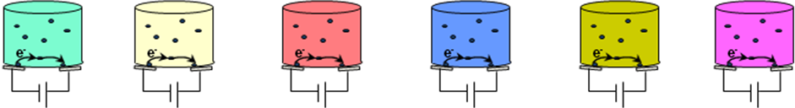

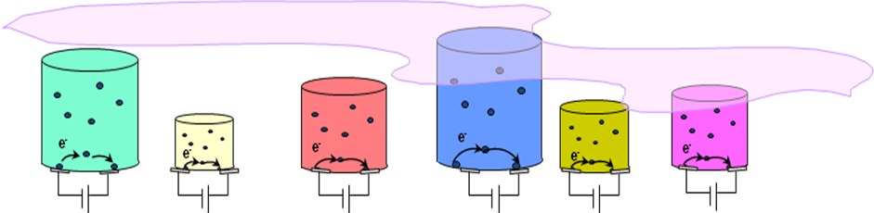

**4.5.2 QUARTZ SENSOR**

The vibration of the quartz is changed by a contact between the molecules and the surface. The response and recovery times are minimized by reducing the size and mass of quartz crystal along with the thickness of the polymer coating. The main disadvantage is that they have more complex electronics than of polymer sensors.

**4.5.3 MOSFET SENSORS**

These are based on the principle that VOCs in contact with a catalyst metal can produce a reaction on the metal. The reaction products can diffuse through the gate og the MOSFET to change the electrical properties of the device. The sensitivity and selectivity of the device can be optimized by varying the type and thickness of the metal catalyst and operating them at different temperatures. The advantage is that they can be made with IC fabrication so that batch to batch variations can be minimized.

**4.5.4 OPTICAL FIBRE SENSORS**

A light source of single frequency is used to interrogate the active material, which in turn responds with color change in the presence of VOCs to be detected and measured. The active material contains chemically active fluorescent dyes immobilized in an organic polymer matrix. As VOCs interact with it, polarity of the fluorescent dyes is altered and they respond by shifting their fluorescent emission spectrum. The sensors are cheap and easy to fabricate. The disadvantage is that fluorescent dyes are slowly consumed by sensing process.

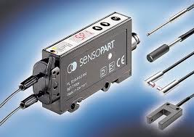

**5. BROADCASTING OF SMELL**

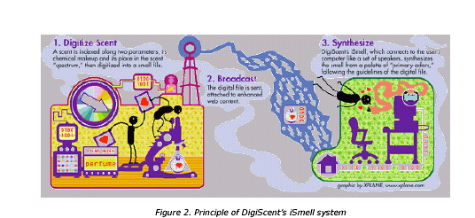

**5.1 Digitized Scent**

A scent is indexed along two parameters, its chemical makeup and its place in the scent”spectrum”,and then digitized into a small file.

**5.2 Broadcast**

The digital file is scent, attached to enhanced web content.

**5.3 Smell Synthesizer**

The smell synthesizer means the device which is used to generate the smells. Such as ismell is device used to produce the gas using computer. There are various types of smell synthesizers available in the market, but for computer the smell synthesizer is made by digiscents industry.

**5.4 The complete product**

DigiScents is developing a complete solution for scent-enabling the Internet and all forms of digital media, including:iSmell Personal Scent Synthesizer: A computer peripheral device which recreates Scent Objects by mixing and releasing one or more of 128 scents. The device includes replaceable cartridges similar to those used in color printers.

**5.4.1 ScentPalette Cartridges**

Consider cartridges contained inside the iSmell device. The cartridges are filled with over one hundred different fragrant materials that are emitted alone or in combination. In addition to the general purpose of Scent Palette there is a possibility of creating industry Specific cartridges for every thing from fragrances and food to games and movies.

**6. DIGITAL SCENT COMMUNICATION**

**6.1 COMMUNICATION MODEL**

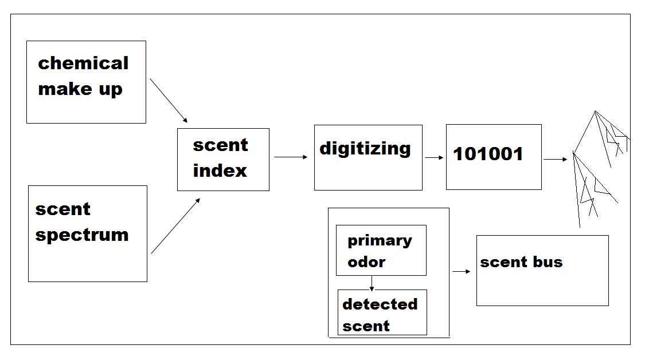

**Fig 6.1.1**

The e-nose detects the smell molecules and it is indexed based on two parameters. The scent is indexed according to its chemical makeup and its place in the scent spectrum. The chemical makeup can be detected by the electronic nose which otherwise act as the receiver. Like the color spectrum, there is also scent spectrum and any smell will be the indexed smell of primary smells in the scent spectrum. The indexed scent is digitized into a small file by olfactory signal processing. This file is sent as an attachment to the recipient’s computer. At the receiving end, there will be a personal scent synthesizer and air cannon. The personal scent synthesizer reproduces the smell and the air cannon direct the smell to user’s nose. The data about the smell is given by the digitally encoded file which is transmitted. The smell emitted will be in the form of vapors.

**6.2 SCENT SYNTHESIZERS**

Scent synthesizers are devices which are used to generate the smell in accordance with the digitized file that is transmitted through the web. The scent synthesizers are interfaced with our PC through a USB port. It can be programmed or installed and it generates a small quantity of smell vapors into the surrounding that is enough to feel the smell. All scent synthesizers will have are movable cartridge which is used to mix different primary odors in different scent synthesizers. *Digi scent* is the company which identified the most number of primary scents about 128 primaries and they could create up to 1000 smells using these primaries.

**6.2.1 CATRIDGE USED IN PERSONAL SYNTHESIZERS**

The personal synthesizers that produces the desired smell has a cartridge inside it which is disposable as the chemical inside it wear out. Different types of cartridges are manufactured according to the primary smells it can contain.

There will be 19 types of smell creating chemicals in the cartridge and by using different proportions of these smells we can create many secondary smells. The principle of operation of each cartridge is the same.

The cartridge use direct molecular heating or static heating technology. The cartridge shown below has a container whose sides are made up of glass plate.The electrodes can be arranged as follows.

There is a common cathode which is situated at the bottom. The container has 19 partitions and separate anodes are dipped into each partition. The electrolytes taken in each separate partition are chemicals which could produce the primary smells. The chemicals are either derived from bacteria or from plants. These electrolytes contain those odor molecules which could lock with the proteins triggering the neuron, which sends a signal that the brain recognizes the smell.

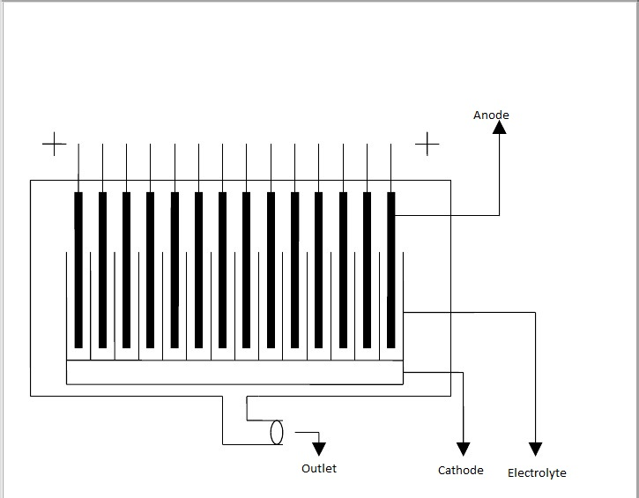

**Fig 6.2.1.1**

These chemicals are partially conducting. Also electrolytic heating of these chemicals is used here. All electrolytes should be heated simultaneously. When dc voltage is given across the electrodes the electrolyte will start to get heated.

According to the different anode voltages applied across each anode, the electrolyte get heated differently and the heated electrolyte from each chamber produces different volatile molecules in different proportions to give different smells. The amount of heating is restricted by the current flow through the anode which is in accordance with the data file encoded about the particular scent. The different primary smell proportions produced by different chambers are combined to give a particular smell.

**6.3 AIR CANON**

One of the problems of olfactory display is that users would have to wear something on their faces to smell the odor. The air cannon will help us to solve this problem. Air canon is used to transport the scented air directly to the user’s nose without the help of any head mounted device. The user and the air cannon are standing in a remote position and the scent is aimed at the user. The distance between the user and the air cannon is about 1-2m. The user can freely move. The air cannon aim directly at the user’s nose. The odor will not simply diffuse into a room. This prevents that everyone staying in the room from smelling as the target person notices the odor. This way directed delivery of scent is provided with a device that is located on your table, not on your head.

The air cannon consist of

1. Face tracker

2. Air clump launcher

3. Scent generator

The ATR Media Information Science Laboratories developed 3 prototype

systems of air cannon.

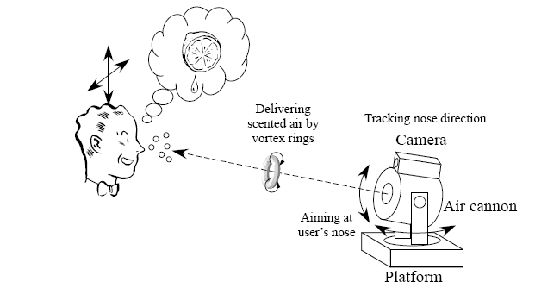

**Fig: General diagram of Air Cannon**

**6.3.1 FIRST PROTOTYPE**

It is simply an elementary electromechanically driven air cannon equipped with a scent generator. It consists of an acrylic box, a scent diffuser and an air pump. The acrylic box is endowed with an aperture at the front and a rubber membrane at the back. The rubber membrane is pushed by two solenoids in parallel. The scented air is injected near the aperture so that the injected air could be immediately launched from the aperture.

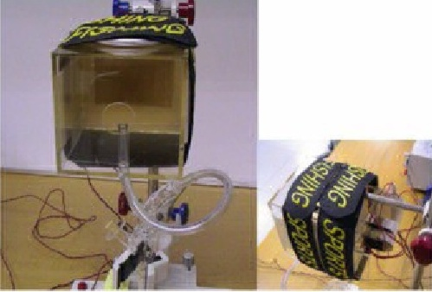

**FIG 6.3.1.1**

Using this prototype, we could display the scent to a restricted are approximately 1m away from the air cannon. The scent is recognized only by the target user.

**6.3.2 SECOND PROTOTYPE**

A vision based nose tracker was used to detect and track the target user’s nose position. After detecting the position of both the eyes, the nose position was detected by searching for the brightest spot within the estimated region in which the nose exists. Once the nose position was detected, the system traces the nose position by template matching and finding the brightest spot.

An ELMO QN 42H micro CCD camera is used for image capturing. The camera was placed just above the air cannon. The nose tracker could trace the nose position at video rate, i.e. 30 times per second.

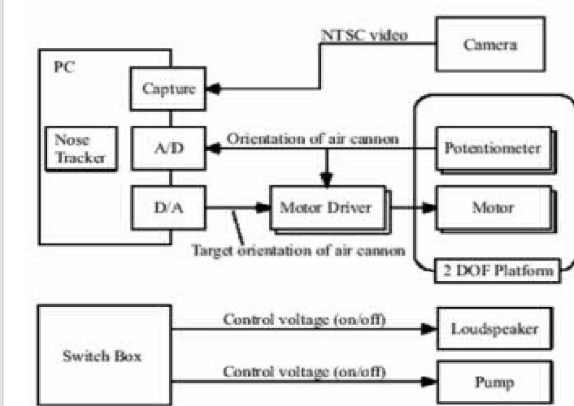

**Fig 6.3.2.1**

The detected nose position was then converted to the desired orientation of the air cannon, which is fed to the motor driver. The platform that carries the air cannon has 2 degrees of freedom and is equipped with a dc motor and a potentiometer for each axis. The rotation speed was 60 degree per second for pan and 75 degree per second for tilt when driven at the rated control voltage. The outputs of potentiometers are used for position control at the motor drivers. With this configuration, the air cannon could continuously trace the nose of the seated user, even if he moved his upper body.

The design of second prototype is nearly equivalent to that of first, except that the driving unit replaces the loud speaker used. This change was intended to suppress the sound when the solenoids impacted the plate attached to the rubber membrane. The scent generator is also same as the first. The operator activates the scent generator before he launches the clump of scented air.

**6.3.3 THIRD PROTOTYPE**

A scent switching mechanism is incorporated in the third prototype system. In the previous prototypes, we could present only a single kind of scent to the user because some portion of scented air diffuse into the air cannon body, where it was difficult to eliminate previously injected scent.

To solve this problem, they attached a short cylinder with the same diameter as the aperture of the air cannon and equipped with mechanical shutters at both the ends. There are 5 holes on the surface of the cylinder for air intake and evacuation. A tube is connected to each hole, through an air valve to a pump. There is also a valve on the body of the air cannon for intake of fresh air.

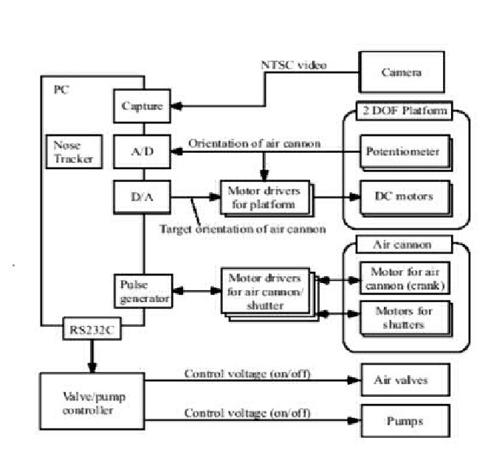

**FIG: 6.3.3.1**

**7. APPLICATIONS**

There are many applications for digital scent technology such as:

* send scented email

* watch scented DVD's

* play scented video games

* sample a perfume from a beauty product's website

* smell the assortment of freshly brewed coffees for sale in their online store.

**7.1 Why Would You Want to Do This?**

In addition to revolutionizing gaming, digital scent technology will bring consumers more lifelike and memorable experiences with scented movies and music, websites, e-mail, e-commerce and online advertising.

There are three basic types of applications that scentware seems a logic fit for at the moment.

* **Entertainment**

Scent will make music, movies and interactive games life like and immersive. Scent tracks will be synchronized with movies, much liked musical score and sound track, in order to create foreshadowing and to establish atmosphere, mood, sense of place and character.

* **Education**

Scent is an effective teaching tool for subjects such as Geography, History and Sciences. With digital scent technology, you can travel anywhere in the world or to any time period in the past.

* **Medical**

Aromatherapy is a kind of curing certain diseases by using different types of smell. It helps in identifying dementing brain disorders including Huntington’s and Parkinson’s and for differentiating them from other mental disorders. This method is based on detecting the olfactory defaults that are diagnostic of the dementing diseases.

**7.2 Multisensory Marketing:**

Death to Banner Ads - Let the Nose Lead the WayCommerce tends to lead development, which is why some of the bigger scentware developers, like TriSenx, are partnering with companies that just plain smell. Perfume manufactures are an obvious fit. They would be able to benefit from doing market research across the net, emailing you samples of some new fragrance they might be trying out to see how you like it, and using your feedback to shape the final product. And the heck with scratch-and-sniff cards in your favorite magazine. Now you’ll smell their latest and greatest when arrive at your favorite women’s website or online boutique.

Other companies who’ve taken the bait besides the cosmetics, fragrance, and health and industries? - restaurants and specialty food shops who know the smell of pizza wafting out of your PC, or may be mom’s chocolate chip cookies, will just be too much too resist. It adds a new dimension to the point-of-sale marketing angle. You’re visiting a website that is known to attract a large number of people from particular demographics. The heck with banner advertising when the marketer has a better way to get you hooked on what they’re hocking.

**7.3 Online Interactive Games**

Imagine smelling the scent of an opponent in an interactive online role-playing game or smelling the damp cave your character is trapped in. Games with scented environments, entities and prizes are more immersive and realistic. Scented games will soon be the standard in interactive media, just as games with sound became prevalent as soundcards became common.

**7.4 Communication**

Scent offers developers as well as consumers another medium for creativity and self-expression. Scented web sites, electronic greeting cards and e-mail will enliven all e-communication. With iSmell technology, you can travel anywhere in the world or to any time period in the past.

**7.5 E-Commerce**

Scent will bring the online shopping experience to life. Scent-enabled shopping sites will be more compelling if you can actually smell perfume, flowers, food and beverages, cigars, and exotic places.

**7.6 Advertising**

Vendors of food, cosmetics, home care products, and travel related services can use scent to make advertisements more engaging and memorable. Eventually, like musical jingles and graphical logos, scented banner ads will make it possible to communicate the key feature of scented products or to simply evoke a certain feeling

**8. EFFECTS OF DIGITAL SMELL FOR DIFFERENT SITE**

**8.1 Over the Theater**

After some time the virtual theaters will come in the market. This virtual theater is basically the concept of the virtual reality. These theaters will have electronic hand gloves, digital smell synthesizer, multipoint surround sound system, movement controllable seats, 3d goggles. From this idea the multipoint surround sound system, 3d goggles, movement controllable seats were completed. Now for the user to fill more realistic effects of movies they were introducing the very new facility of digital smell in movies or in games. For example if we are watching a movie and we see burning of tier then we will fill that smell in theater.

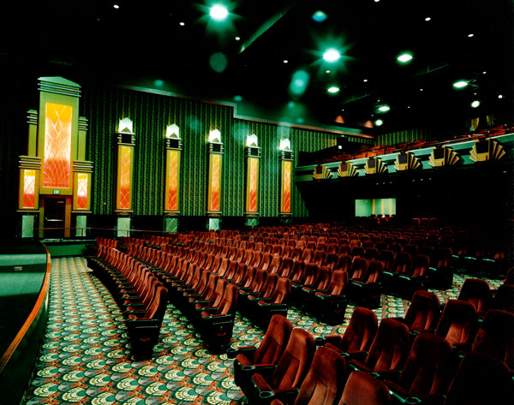

**8.2 Over the Television**

Now a days as new and new sound technology came in picture our home television is changing, getting more and more powerful sound with it. After some time over television will came will more clear picture, better voice as well as ismell device, which will create more interest in watching the television.

**8.3 Over the Internet**

DigiScents technology will be used to add a new dimension to e-commerce and entertainment technology: adding scent to movies, online advertising and interactive games are just a few of the possibilities. "Online greeting cards will be one of the first big plays. We digitize and broadcast scent over the Internet and analyze the molecular structure and sensory perception of an odor and software-code it. The iSmell is a peripheral that is the size of an electronic pencil sharpener; it connects to a USB port. Its scent cartridge would be like a color printer cartridge but with 128 scent elements to combine. These elements will combine to make thousands of scent combinations. "Humans detect around 10,000 smells in their lifetimes. We're going to create the primaries of smell. The company is also creating a Snortal, a first-of-its kind Internet site on which people can create scented e-mail and their own custom scents. Beta testing is currently under way, and final products will be released in fall 2002.

**8.4 E-mail Alive with smell**

Of all the uses for scentware, this one scares be most the ability to send emails with smells anybody can design. Sure, it’ll add a fun new dimension to birthday when you can send an electronic postcard with nice music and a dozen

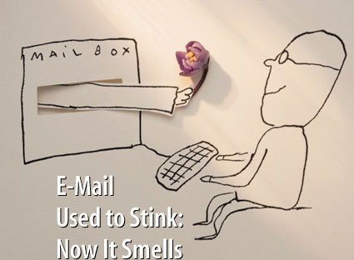

roses that smell real, but can you imagine the legions of alternatives your friends (and others) will opt for? Dirty sneakers, wet dogs May be worse assaults to your delicate sensibilities will be within the reach of email artists and spammers alike.

For authors and music composers the idea of adding taste and smell to their creative conjuring seems irresistible. Words can be powerful stimulators of imagined tastes and smells, but the ability to bring those exact things to life may make the electronic distribution of storytelling an even more tempting channel. Perhaps a glimpse of the evolution of mega bookstores and internet cafes?

**8.5 Education**

Tapping into Another Information Channel. You need only to walk into a bakery or popcorn-filled theatre to realize the powerful ability of smell to invoke memory.

It’s this power that makes the addition of scent to the classroom experience such an interesting new ally. I don’t know about you, but reading about Shakespeare or Napoleon out of a textbook was rarely inspiring. Had you given me the chance to “interact” with history through the sites, sounds tastes and smells of that time, you’d probably have had me hooked.

Virtual field trips have become an invaluable tool for bringing important experience into the classroom where time or geography may otherwise prevent them. The addition of Smell is acknowledged as a tool that enhances the memory of that experience, and amount of knowledge that is retained because of it.

**8.6 Medical**

A new Tool for Catching Degenerative Neurological Diseases Early

Aromatherapy will perhaps be one of the big drivers of home computer scentware sales. In addition to ergonomically correct keyboards and mice, music while we work, and even computer-based workouts to help you keep fit, you can now add smell to your list of tools for increasing personal wellbeing. The benefits of aromatherapy go beyond personal pleasure.

**9. FACILITIES**

1. As we now that user can send any type of smell so the ismell is designed in such a way that it will give protection against that smell.

2. The scent cartridges contain mostly natural materials commonly found in the cosmetics, foods and beverages you use every day.

3. There might be possibility that user has allergy from any smell so for this problem the ismell provides locking facility. So that user can lock that particular smell which he doesn‟t like.

**10. LIMITATIONS**

The obvious one is the price. Most home computer users won’t be willing to pay the $250-500+ price tag for the luxury of scratch-and-sniff websites. Some diehard game fans may find the olfactory add-on a worthwhile boost to their multimedia experience, but chances are this technology will find its first strong market in small kiosks and other specialty shops.

While many fragrance manufacturers will find the ability to use scentware for both market research and the generation of new sales, most of the “ScentWare” application available today operate at a very simple level and aren’t capable of reproducing the very complex protein level of molecule modeling that commercial fragrances require. Specialty food marketers will face the same problem. While pizza, popcorn and apple pie are already stock smells in a number of scentware collections, exact replicas of some of the more complex “branded” foods that big distributors want to entice you with just won’t be possible yet. While a few year’s old, the technology is still immature, and will require a committed partners and reasonable investment to customize the results in a way that’s suitable for companies whose smell is their branding.

**11. ADVANTAGES AND DISADVANTAGES**

**ADVANTAGES**

It can be used without fall over hours, days, weeks and even months and can even circumvent problems associated with the use of human panels such as individual variability, adoption, fatigue mental state and exposure to hazardous material. The e-nose is a compact device and so it is portable and reliability is very high. It can identify simple molecules which cannot be accomplished by human nose. It can identify a smell objectively.

**DISADVANTAGES**

There are a few disadvantages to the e-nose technology which includes price.The cost of an e-nose ranges from $5000 to $100,000. Another disadvantage has been the delay between successive tests, the time delay ranging between 2 to 10 minutes during which time; the sensor is to be washed by a reactivating agent, which is applied to the array so as to remove the odorant mixture from the surface and bulk of the sensors active material.

**12. FUTURE WORK**

**The Present**

Digiscents were awarded the “best technology “ prize during the Retail Vision 2001 ceremony, for the past ten years one of the major honor in the IT retailers industry.2,500 developers have already applied for the ScentWare Developers Kit which was launched in March 2000 and is used to create “Scented games and multimedia applications.

**The Future of DigiScents**

They proposed a naval configuration of an olfactory display that does not require user’s to put anything on the face and that localizes the effective space of the displayed scent. The technical key to realizing this concept is to transfer a clump of scented air from a place near the nose, and we confirmed that this is possible by using air cannon. The constructed prototype system successfully displayed the scent to the target user, even if the user moved his head.

They are going to propose another choice in methods to enjoy scent in interactive applications. The wider the variety of olfactory displays, the wider the variety of applications will emerge to make our VR experience rich and realistic.

Improvement of scent generation is necessary to extend the variety of displayed scent and we can learn a lot from preceding research efforts on scent blending and generation. Also precise theoretical analysis of a tropical vortex might be effective for optimal design of the air cannon. They are planning a step by step in order to construct a transparent, easy to use olfactory display system.

**13. CONCLUSION**

A Scent has a strange power over human beings. It can create a mood, such as foreshadowing or ambiance. It can intensify emotions such as fear or love. It can also give the sensation of virtual reality and suspension of disbelief.

“The Sense of smell is closely tied to memory and emotion, making scent a powerful way to reinforce ideas”.

There are several streams over which this digital smell is used, Such as over the television, theater and the web. Hence we conclude that this digital smell will revolutionized the world. And at every place we will require this device, such as for scented mail, scented movies, scented songs we must requires this device.

This device will become our need in future.

**14. REFERENCES**

[1][*www.digiscents.com*](http://www.digiscents.com)

[2][*www.trisenx.com*](http://www.trisenx.com)

[3][*www.aromajet.com*](http://www.aromajet.com)

[4][*www.scentware.com*](http://www.scentware.com)

[5][*www.primagames.com*](http://www.primagames.com)

[6] [*http://en.wikipedia.org/wiki/Electronic_nose*](http://en.wikipedia.org/wiki/Electronic_nose)*.*

[7] [*http://www.digitaldreams-si.com/what-is-digital-scent-technology/*](http://www.digitaldreams-si.com/what-is-digital-scent-technology/)